# How to Create Logic Apps?

Here, we are going to create 1st logic Apps. We are performing following steps to create an Azure Logic Apps.

1. Go to portal.com [Home - Microsoft Azure](https://portal.azure.com/#home)
2. Search for Logic Apps

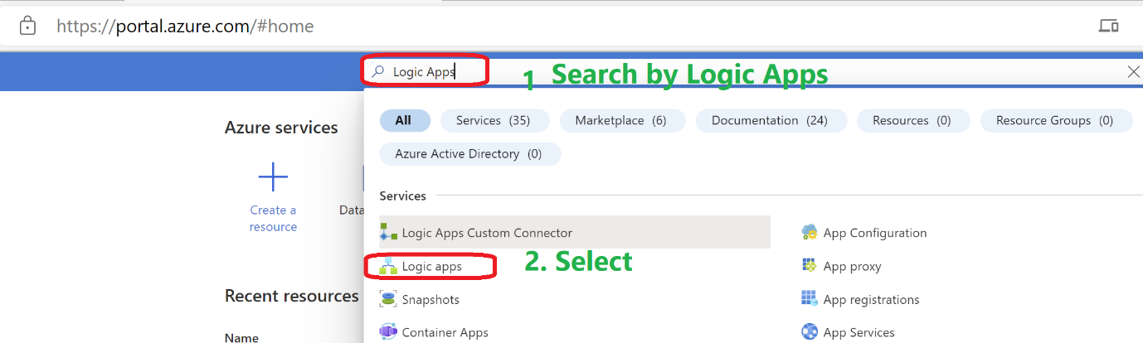

1. Click on + Add

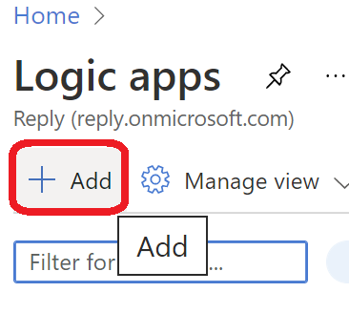

1. Now follow following steps. **Review + Create** will takes few seconds

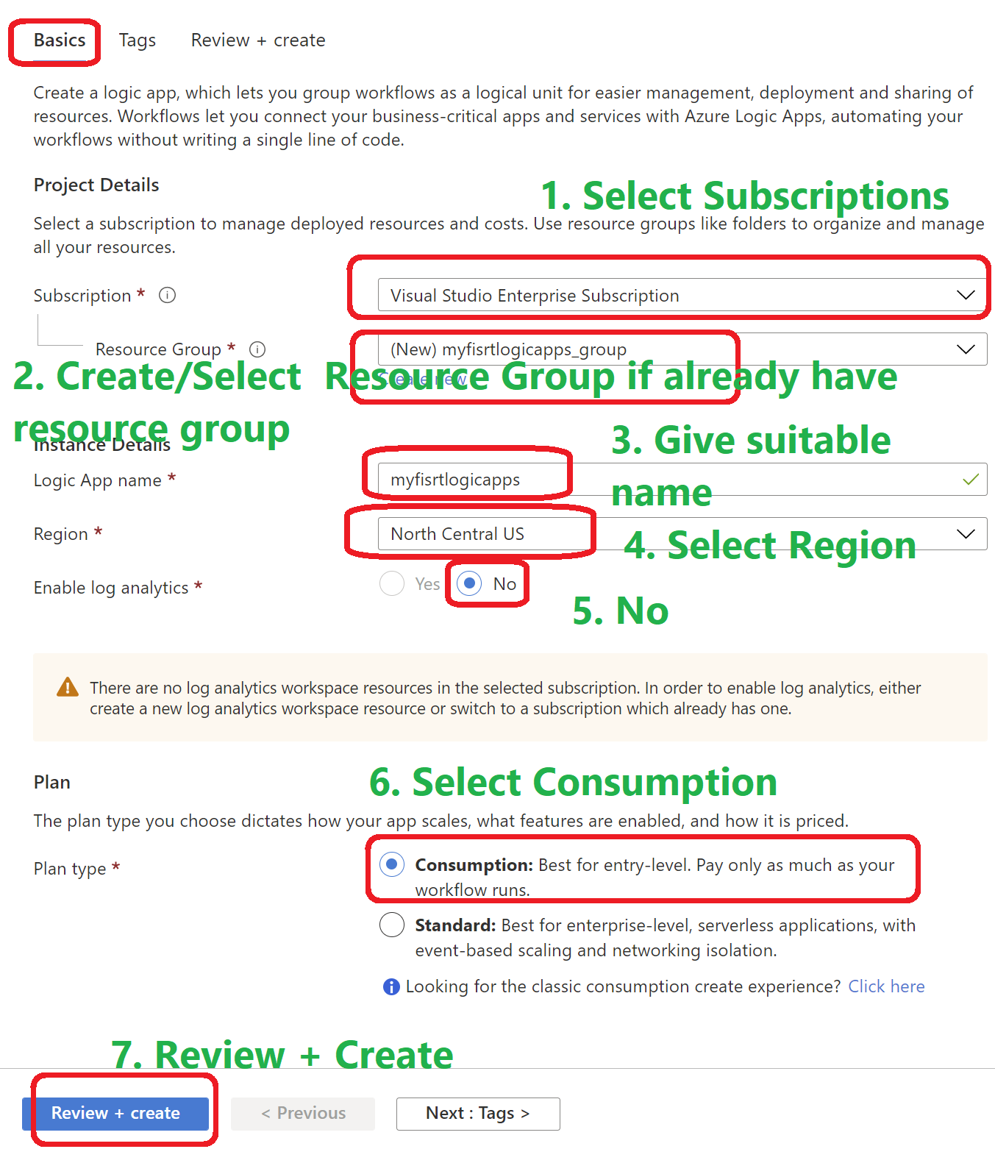

1. Now, Click on Create. It will takes few more seconds

You will see something like this.

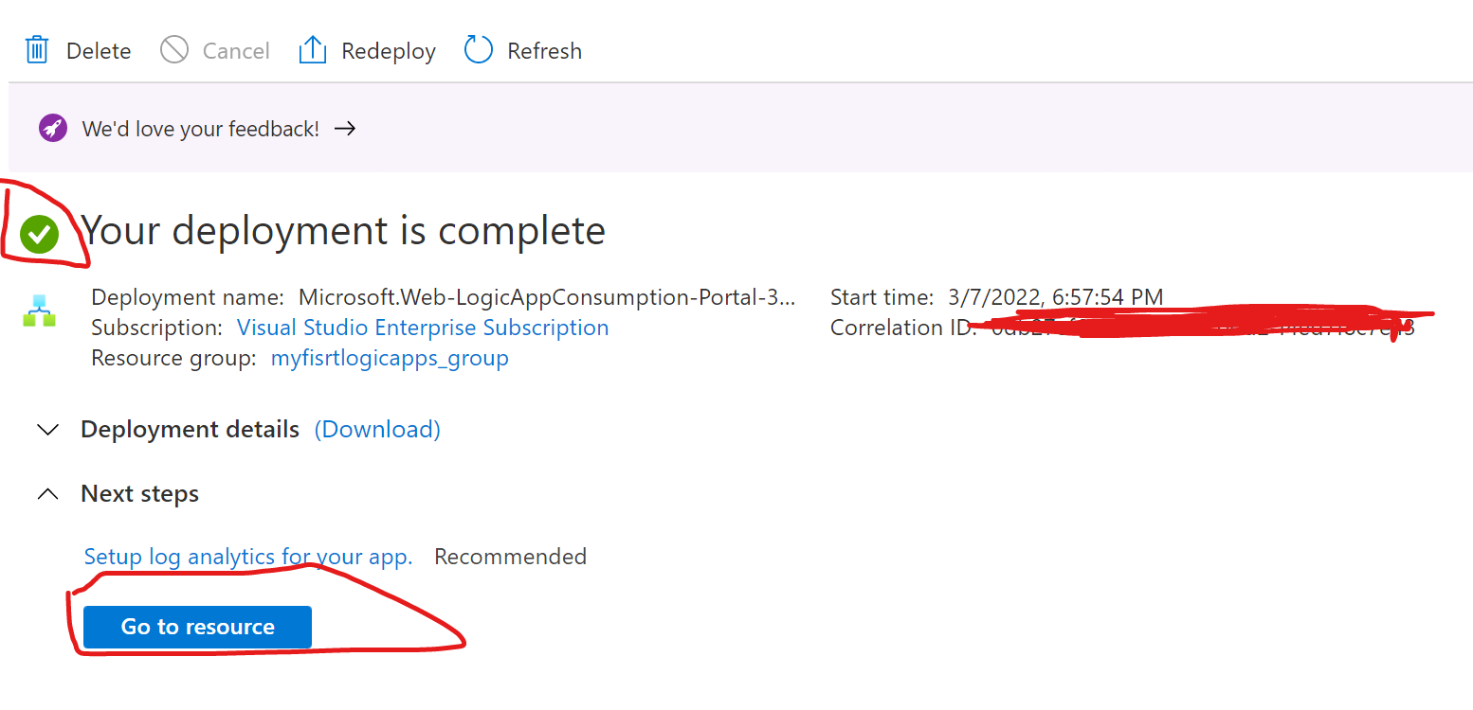

1. Now go to resources.
2. You will see below landing page. Here you can explore many things. You can see readymade templates which you can directly use.

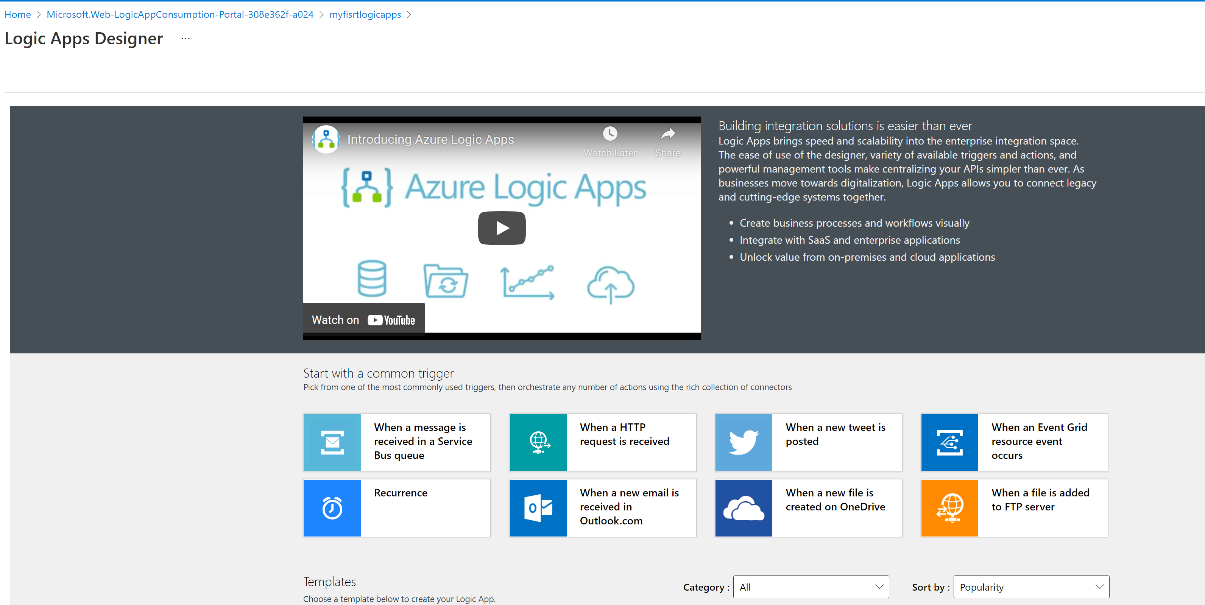

1. Now if you scroll down to left side you can see Left tab having Overview.

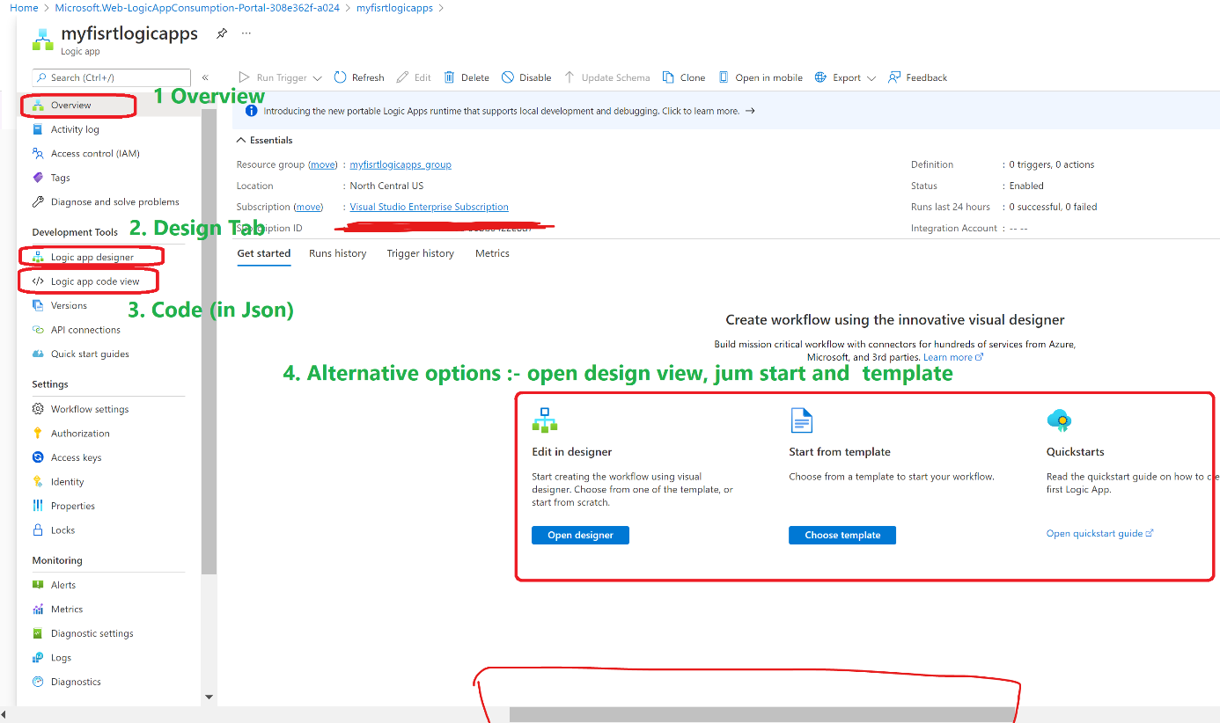

1. Now let’s select Httpt Trigger for your workflow.

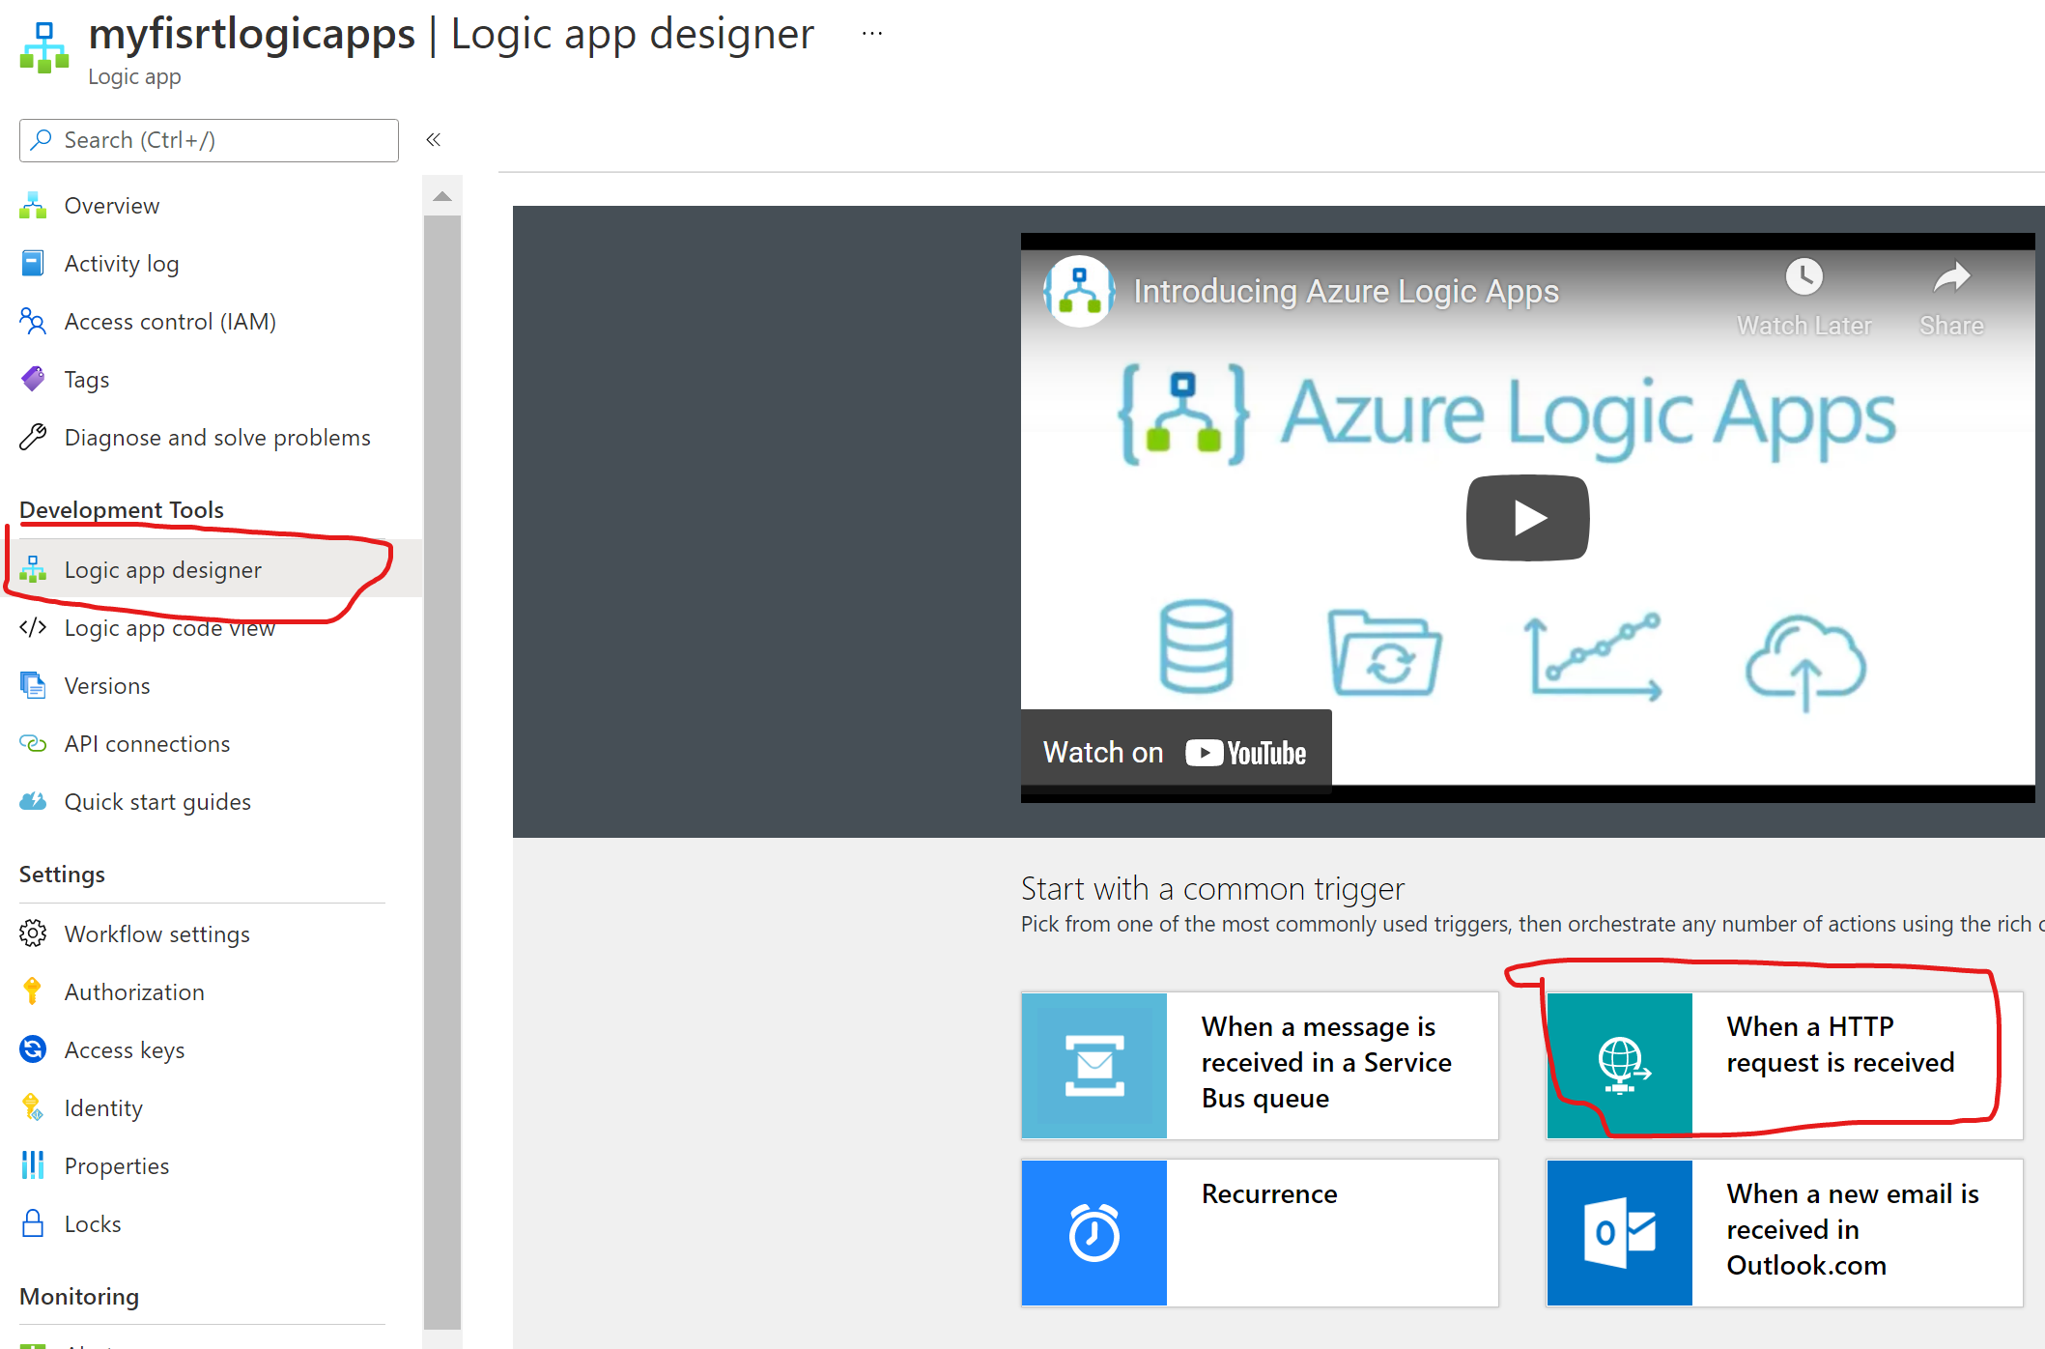

1. You will see it as

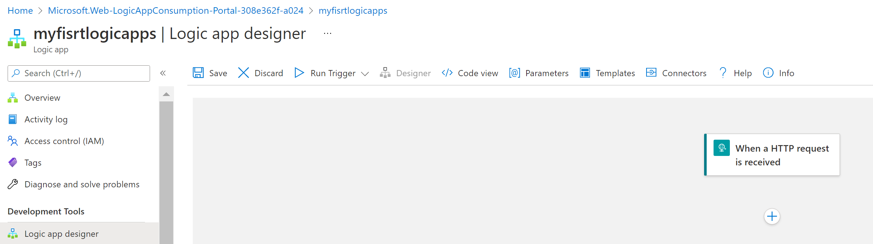

1. Now we have decided http trigger to run your workflow. Now need to add actions so when workflow trigger it perform specific steps.

Click on + Icon

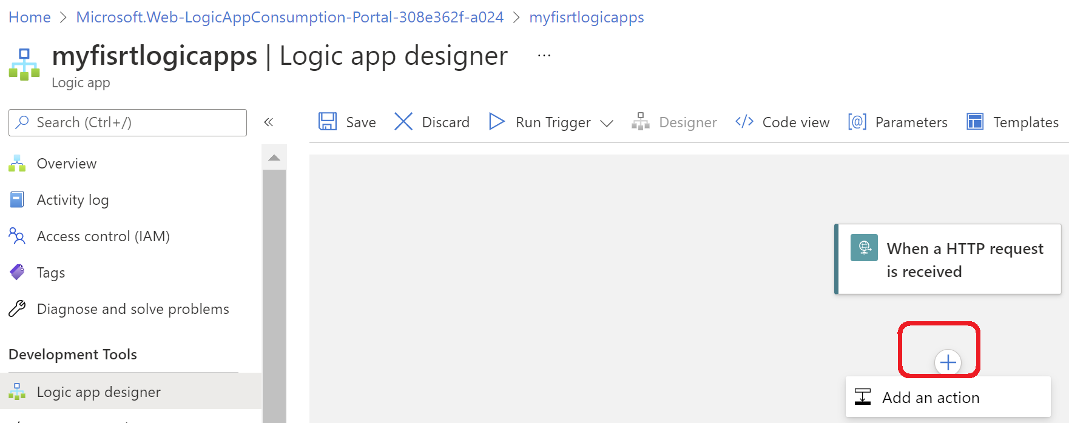

1. Search for **Gmail**. Then select action as **send email(V2)**

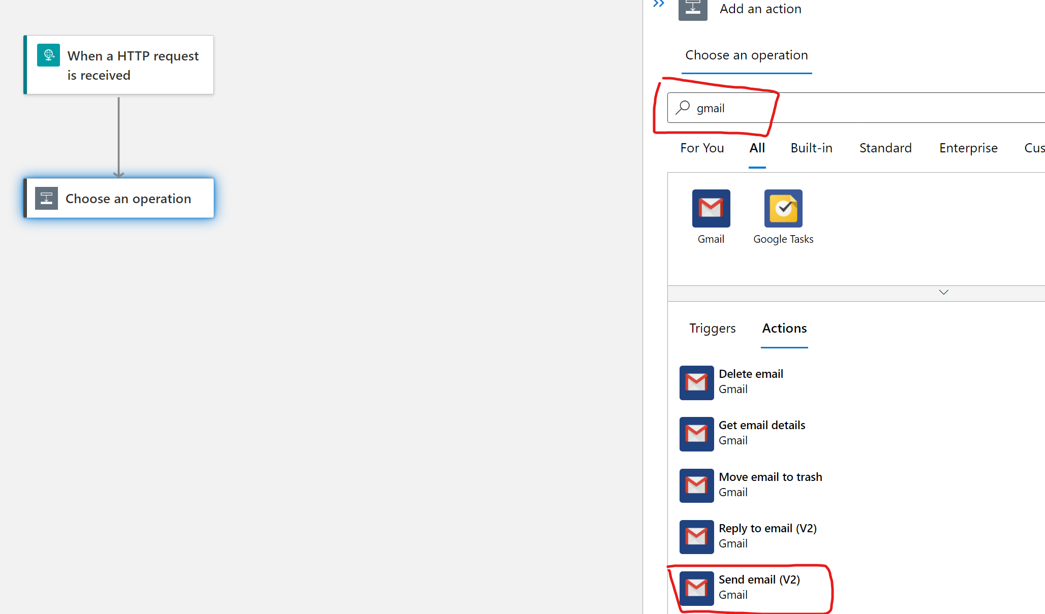

13 Follow few steps to create Gmail connector to send an Email

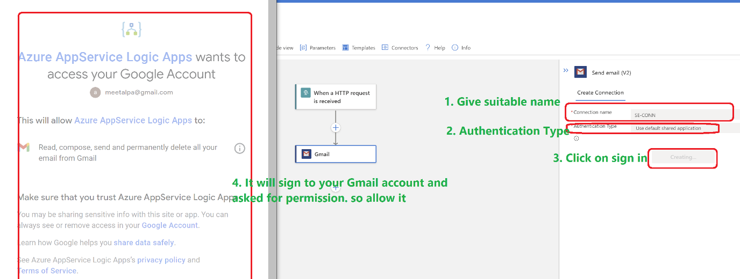

14 After having successful connection, it looks like this

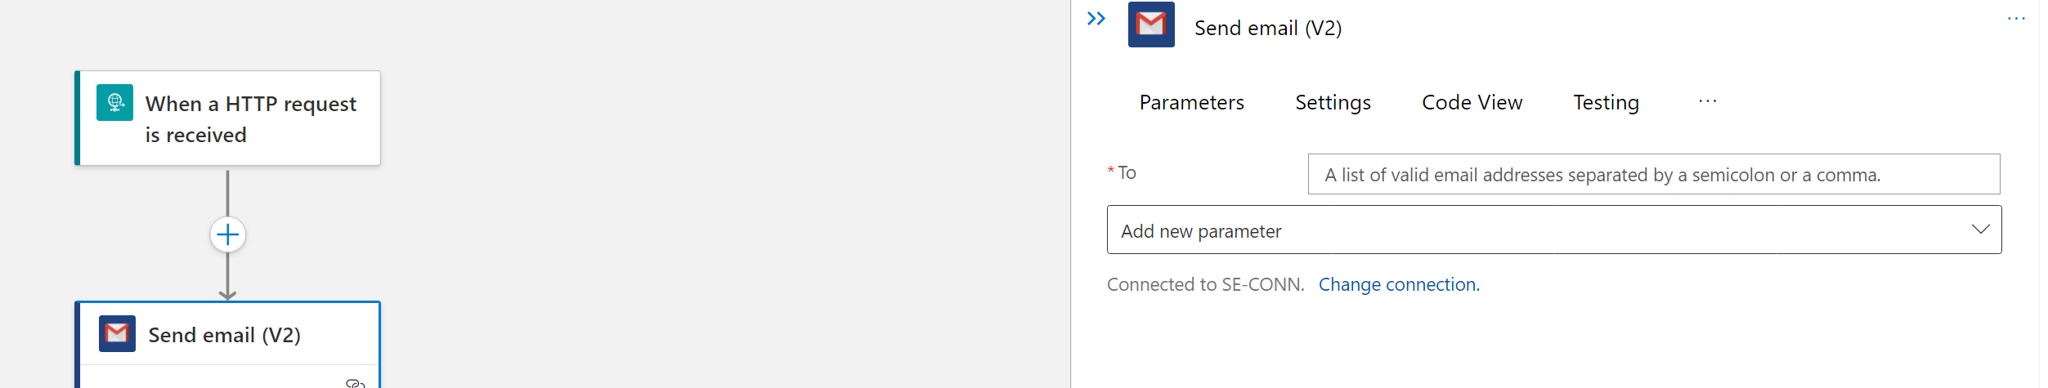

15. Just add recipient and subject or attachment and click on save

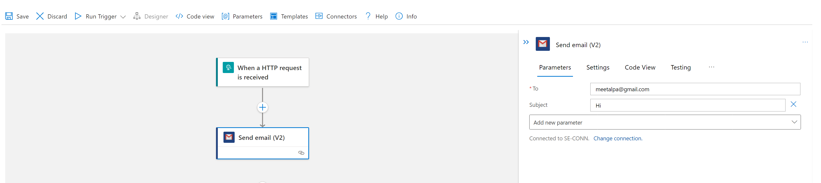

16. Run it

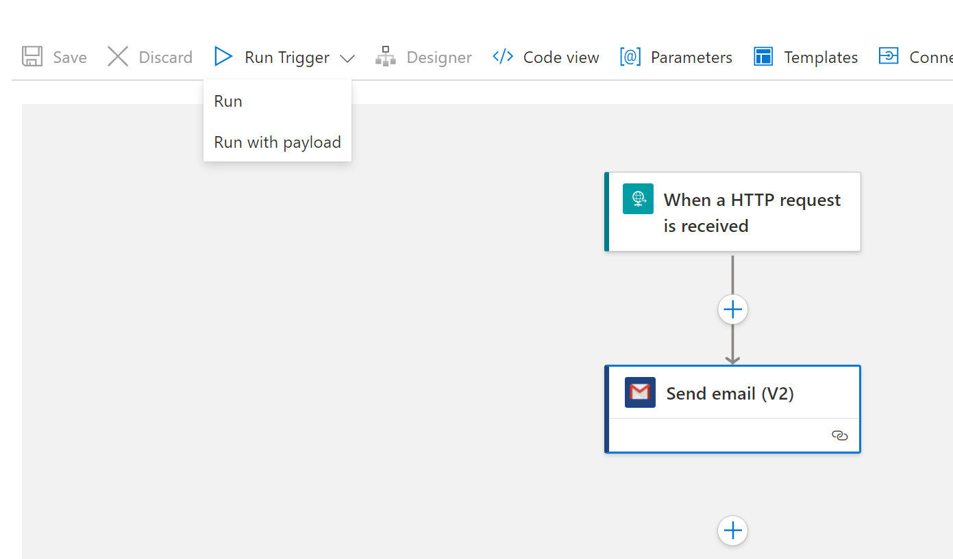

17. You will get screen like .Also you will get an email.

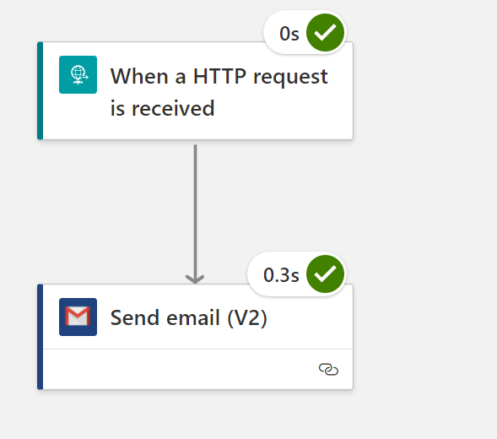

18. You can see run history

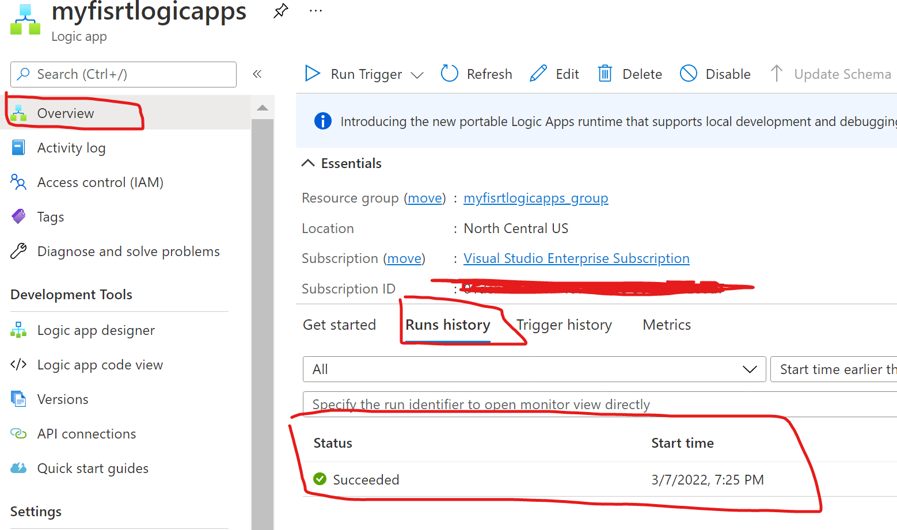

19. Congratulation, you have created your 1st logic Apps

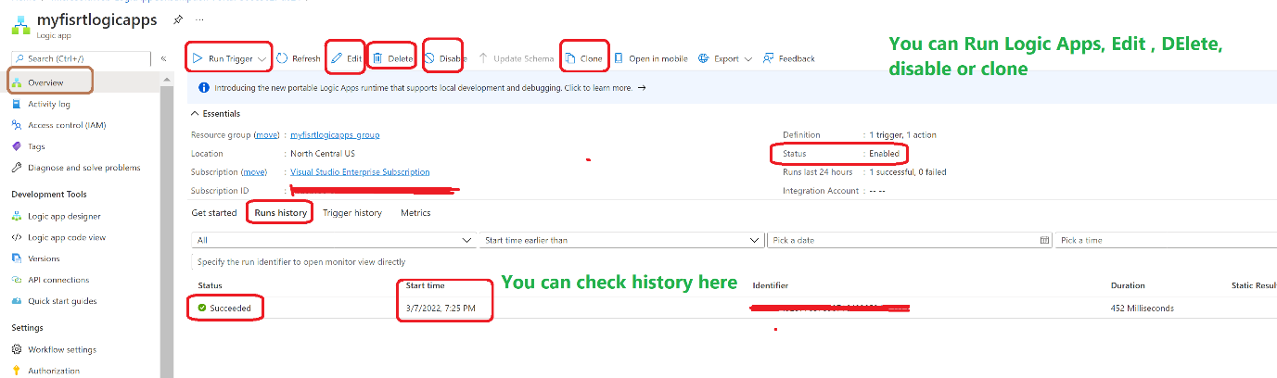

# How to test Logic Apps?

Copy URL from 1st action which is trigger in Logic Apps design.

It is URL which you can easily call via Postman or nay other Azure services such as ADF or Azure synapse analysis etc. using web activity

